User Guide for HR Symphony Time & Attendance Module

- Introduction

For a company with huge numbers of employees and numerous shifts, employees’ attendance data management and documentation often develops into a exhausting and error potentially task. HR Symphony Time & Attendance Module facilitates you to easily manage schedules, time zones, and employee’s attendance with the input of attendance machine. It contains time zoning functions (Day Change Judge, Zone Setting), scheduling functions (Schedule, Calendar), and attendance time management functions (Time Rounding, Break, Hours Rounding).

- Setting Types

Before operating this module, there are some essential setting types to comprehend. They are divided into three functions, namely: time zoning, scheduling and attendance time management functions.

Time Zoning Functions

Basically there are two time zoning functions, namely Day Change Judge, Revision Zone and Zone Setting.

Day Change Judge concerns date assessment when one shift expands one-day expiration time. There are four types of Day Change Judge, namely: Day Change Time Before and After Midnight, Day Change Extension Before and After Midnight.

Day Change Time (DCT) is the time when any entrance/exit is considered to be in the day before/after the actual date.
DCT Before Midnight resides in the time before 00:00, while DCT After Midnight in the time after 00:00.

Day Change Extension Hours is the extension hours of DCT.

Shift setup |  |  |  |  | Employee’s attendance |  |  |  | Adjusted attendance
 |  |  |  |  | IN |  | OUT
Shift name | IN | OUT | DCT | DCE | Date | Time | Date | Time | Shift | Date
D1 | 08:00 | 16:30 | 03:00 | 04:00 | 11/01/2001 | 16:00 | 11/02/2001 | 03:00 | D1 | 11/01/2001
D2 | 21:00 | 03:00 | 07:00 | 09:00 | 11/01/2001 | 23:00 | 11/02/2001 | 09:30 | D2 | 11/01/2001
M01 | 00:00 | 08:30 | 19:00 | 20:00 | 11/01/2001 | 23:30 | 11/02/2001 | 20:10 | M01 | 11/02/2001
N1 | 16:00 | 23:00 | 00:00 | 02:00 | 11/01/2001 | 18:00 | 11/02/2001 | 02:30 | N1 | 11/01/2001

Zone Setting
This function defines how working time divided on its importance. There are two types of zone setting, namely:
- Regular zone: This zone covers the most common time for work.
- OT Zone: It occupies what regular zone doesn’t

Revision Zone
It is a tolerance zone for employee’s arrival and departure.
There are four types of revision zone, namely:
- Paid IN: any entrance within this time zone will be paid
- Unpaid IN: any entrance within this time zone will not be paid
- Paid OUT: any departure within this time zone will be paid
- Unpaid OUT: any departure within this time zone will not be paid

Here’s an example:

Revision Zone Type | Schedule |  | Revision Zone |  | Employee’s Attendance |  | Adjusted Attendance
Revision Zone Type | IN | OUT | START | END | IN | OUT | Adjusted Attendance
Paid IN | 08:00 | 16:00 | 08:00 | 08:15 | 08:11 |  | 08:00
Unpaid IN | 08:00 | 16:00 | 08:00 | 08:15 | 08:11 |  | 08:15
Paid OUT | 08:00 | 16:00 | 15:50 | 16:00 |  | 15:52 | 16:00
Unpaid OUT | 08:00 | 16:00 | 15:50 | 16:00 |  | 15:52 | 15:50

Scheduling Functions

These are functions that deal with organizing working schedule for employees. There are two scheduling functions in this regard, namely Schedule and Calendar.

There are four types of Schedule function, namely:
- Auto
This schedule type is set automatically by input from attendance machine. Employee’s first entrance sets his/her shift, which further sets his/her schedule as well.

Shift setup |  |  |  | Employee’s |  | Employee’s adjusted shift
Shift Name | IN | OUT | First IN | Shift | First IN | Employee’s adjusted shift
D1 | 08:00 | 16:30 | 07:00 | D2 | 18:15 | N1
D2 | 21:00 | 03:00 | 20:00 | D1 | 09:05 | D3
D3 | 08:00 | 08:30 | 09:00 | D3 | 07:40 | D1
N1 | 16:00 | 23:00 | 18:00 | M01 | 20:50 | D2

- Manual
This schedule type can interfere other types manually, since it owns the highest priority. When an employee swipes in, the system will have no choice but to record this entrance, disregard any schedule type employed.
- Pre-schedule
This schedule type is set to carry out the schedule period.
- Fixed Schedule
Employees work in the same shift everyday
- Roster (Rotation Schedule)
This schedule repeats automatically every time it reaches the end of setup period. It may also be inserted by Auto schedule.

Calendar function sets work and off days throughout the year.

Time Management Functions

These are functions that deal with work hours rounding, and break hours, as well as parameters related to them.

Time Rounding
These are functions relate to employee’s unpunctuality time estimation. There are two properties of Time Rounding, namely Rounding Unit and Break Point. Rounding Unit is the range of rounding estimation, while Break Point is the point to decide the rounding extremity.
Example:

Rounding Unit | Break Point | Schedule |  | Employee name | IN | IN (Adjusted)
Rounding Unit | Break Point | IN | OUT | Employee name | IN | IN (Adjusted)
15 minutes | 8 minutes | 08:00 | 16:00 | Zahra | 08:05 | 08:00
 |  |  |  | Anton | 08:11 | 08:15

Break
These are functions that concern types of break (paid/unpaid), which includes Fixed, Automatic, Flexible Break Deduction and Paid Break.

Break type | Zone |  | Hours
Break type | Start time | End time | Work | Break
Fixed Break
Automatic break deduction
Flexible break deduction
Paid break

- Fixed break: This type needs break zone. Unless the end time is reached, any entrance within this zone is not regarded as work hours.
- Automatic break deduction: It automatically deducts work hours when employee works for a certain duration, and/or swipes out beyond break zone.
- Flexible break deduction: The break zone in this type is flexible one, since it contains two zones; flexible and strict zone.
- Paid break: Any break in this zone is regarded as work hours, and paid. It can be applied to Fixed Break and Flexible Break Deduction only.

Break type | Apply Paid Break? | Actual |  | Adjusted Break
Break type | Apply Paid Break? | Break | Worked | Adjusted Break
Automatic Break Deduction | Yes | > Setup Break | > Work Setup | = Setup Break
Automatic Break Deduction | Yes | < Setup Break | > Work Setup | = Actual break
Automatic Break Deduction | Yes | > Setup Break | < Work Setup | = Setup Break
Automatic Break Deduction | Yes | < Setup Break | < Work Setup | = Actual break
Automatic Break Deduction | No | > Setup Break | > Work Setup | = Actual break
Automatic Break Deduction | No | < Setup Break | > Work Setup | = Setup Break
Automatic Break Deduction | No | > Setup Break | < Work Setup | = Actual break
Automatic Break Deduction | No | < Setup Break | < Work Setup | = Setup Break
Flexible Break Deduction | Yes | < Setup Break | X | = Actual break
Flexible Break Deduction | Yes | > Setup Break | X | = Setup Break
Flexible Break Deduction | No | < Setup Break | X | = Setup Break
Flexible Break Deduction | No | > Setup Break | X | = Actual Break

Hours Rounding
These are functions that concern types of rounding total work hours. It also has two properties, similar to those of Time Rounding. There are four types of hours rounding, namely:
- Total Worked Hours: It rounds the total worked hours according to the rounding scheme
- Individual Worked Hours: It rounds worked hours before and after break time individually, and then adds them to reach the total hours.
- Total Break Hours: Total worked hours is subtracted by total break hours, and then the result is rounded.
- Individual Break Hours: It rounds each break individually, and then adds them. Finally, the result deducts total worked hours.

Rounding type | Rounding unit | Break point | First IN |  | OUT | IN | Last OUT |  | Total worked hours
 |  |  |  |  |  |  |  |  | Actual | After rounding
Total work hours | 15 | 8 | 08:03 |  | 12:11 | 13:00 | 17:08 |  | 8:16 | 8:15
Total work hours | 15 | 8 | 4:08 |  |  | 4:08 |  |  | 8:16 | 8:15
Individual work hours | 15 | 8 | 08:03 | 12:11 |  | 13:00 |  | 17:08 | 8:16 | 8:30
Individual work hours | 15 | 8 | 4:15  (Rounded) |  |  | 4:15  (Rounded) |  |  | 8:16 | 8:30

Rounding type | Rounding Unit | Break Point | First IN | OUT | IN | OUT | IN | Last OUT | Total work hours
Total break hours | 15 | 8 | 08:00 | 10:03 | 10:41 | 12:00 | 12:08 | 17:00 | (17:00 – 08:00) – 0:45 = 8:15
 |  |  |  | 0:38 |  | 0:08 |  | 17:00 | (17:00 – 08:00) – 0:45 = 8:15
 |  |  |  | 0:46 0:45 (rounded) |  |  |  | 17:00 | (17:00 – 08:00) – 0:45 = 8:15
Individual break hours | 15 | 8 | 08:00 | 10:03 | 10:41 | 12:00 | 12:08 | 17:00 | (17:00 – 08:00) – 1:00 = 8:00
 |  |  |  | 0:38 0:45 (rounded) |  | 0:08 0:15 (rounded) |  | 17:00 | (17:00 – 08:00) – 1:00 = 8:00
 |  |  |  | 1:00 |  |  |  | 17:00 | (17:00 – 08:00) – 1:00 = 8:00

- Getting Started

For security reason, we provide a Login window that requires you to enter your username and password.

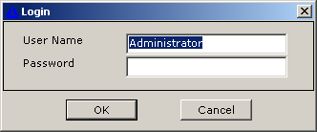

Once you click OK, you are gaining access to HR Symphony Time & Attendance Module.

- Main Menu

When you are logged into the system, you will see the main menu below.

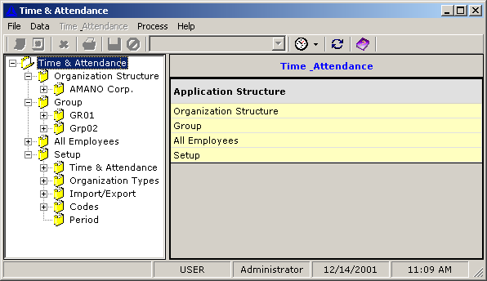

Time Management folder is the gate to all the information in this module. By double clicking, you will see its subfolders; namely Organization Structure, Group, All Employees and Setup.

Organization Structure covers all the information about the organizations. If you click an organization name, its subfolders will appear. The subfolders cover information of organization’s hierarchy and details (ID, Display Name, Name, Level, Manager, Homepage). To view organization’s hierarchy, click organization subfolder.

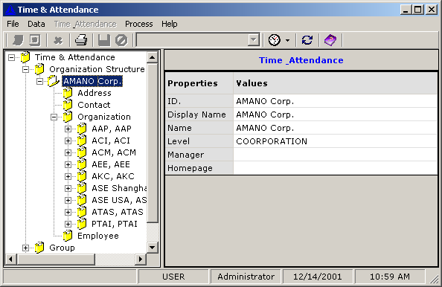

Group covers information about employees’ group. In addition to information about Display Name, Name and Group Coordinator, it covers information about group’s shift (Description), Schedule, and Start date of the schedule as well.
Employees of one group belong to a particular schedule set in Schedule.

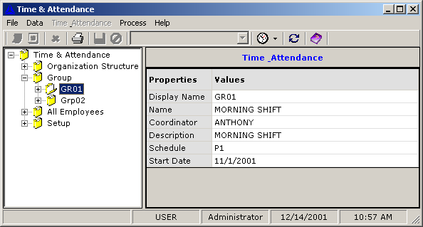

All Employees covers information about employees of all organizations in the specified organization structure.

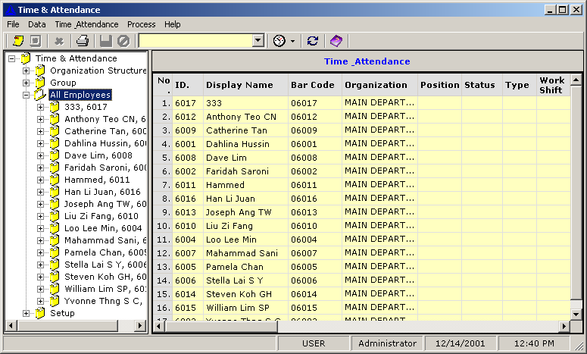

Setup functions include Time & Attendance setup, Organization Type setup, Import/Export setup, Codes setup and Period setup.

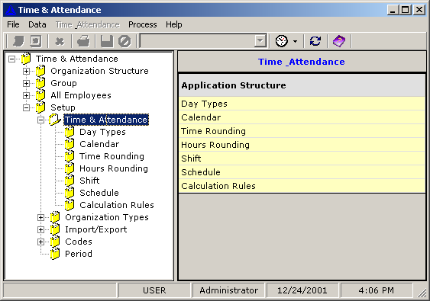

Time & attendance setup includes:

- Day Types
It sets types of day for Calendar setup purpose.

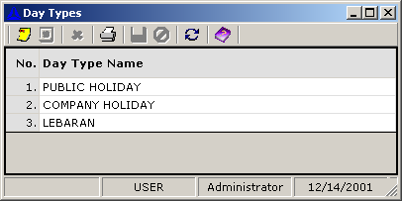

- Calendar
It sets the distribution of day types through out the year.
Calendar denotes a specific calendar name, which later will be employed to Schedule setup.
The Day Types set above are applied here. You may click the check box to match a particular date to a specific day type.

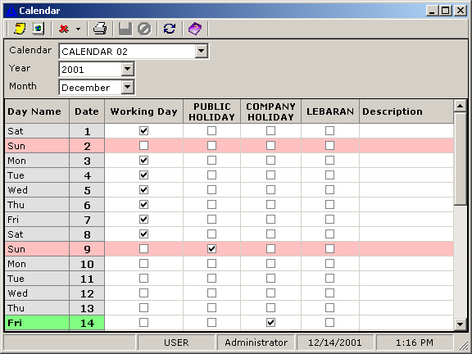

- Time Rounding
It sets the time rounding estimation. Code and Name specifies time rounding code and name, respectively. See the explanation of Rounding Unit and Break Point in Time Management section.

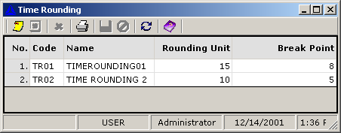

- Hours Rounding
It sets the hours rounding types. Code and Name specifies time rounding code and name, respectively, while Type specifies the hours rounding type. You may select a type of four options available. See the explanation of Rounding Unit, Break Point and hours rounding Type in Time Management section.

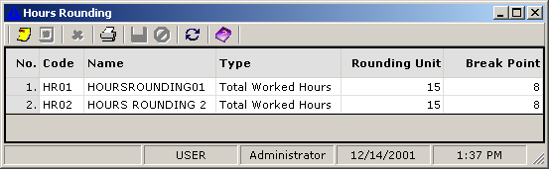

- Shift
It sets the properties of shift. There are three windows in Shift setup.

- Window that only covers main properties of shift, namely:
  - Code Number: set a specific code number for a particular shift. There are 100 code numbers, ranging from 0 – 99.
  - Code: specify the shift code. It is essential for schedule setup
  - Name: set the shift name
  - First IN: set the time of shift’s first entrance
  - Last OUT: set the time of shift’s last exit
  - Rounding: set the types of time rounding and work hours rounding (see the explanation in Time Management section)
  - Day Change: set the Day Change Time and Day Change Extension (see the explanation in Time Management section)
- Window that covers break type properties:
  - Break Type: select the break type to apply (see the explanation of break in Time Management section)
  - Paid Break: ask your preference whether to apply paid break on a particular break.
  - Zone: set the zone start and end for a particular break
  - Hours: set the break and work hours (for Automatic Break Deduction and Flexible Break only)
- Window that covers revision zone properties:
  - Revision zone type: select the Revision zone type
  - Start: set when the Revision zone starts
  - End: set when the Revision zone ends

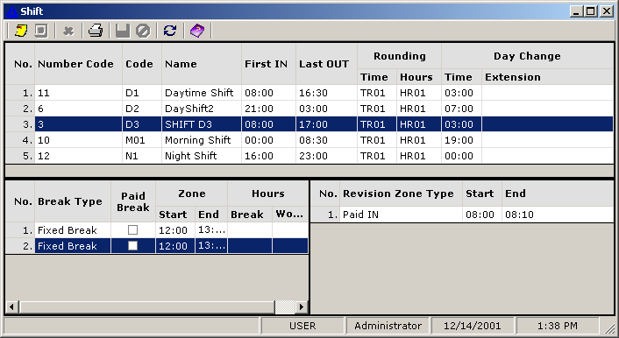

- Schedule
It sets the schedule types. There are two windows in the Schedule setup:

- Window that covers properties of all schedule:
  - Code: set a specific code for a particular schedule
  - Name: set a schedule name
  - Type: select a schedule type (see the explanation of schedule type in Scheduling Function section)
  - Calendar: select a calendar name (see Calendar setup)
  - Start date: set the date when the schedule application starts
  - Days: set the schedule application number of days
- Window that covers properties of one particular schedule only:
  - Type: set the attendance type (Shift/Schedule) in the particular day order
  - Code: set the code of attendance (see the Shift setup) in the particular day order
  - Day: set the day order
  - Start FIRST IN: set the time of first entrance of the schedule

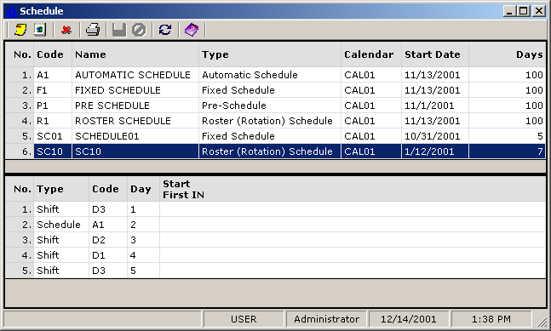

- Calculation Rules
It sets the calculation rules applied in the whole system. There are three windows that ask your preference on calculation rules to apply:
- Window that ask your preference on time management function to apply:
  - Use Revision Zone: ask your preference on applying revision zone in calculation process
  - Use Time Rounding: ask your preference on applying time rounding in calculation process
  - Use Work Hours Rounding: ask your preference on applying work hours rounding in calculation process
- Window that ask your preference on daily script to apply
- Window that ask your preference on period script to apply
(See the explanation of script on the Time & Attendance Script section)

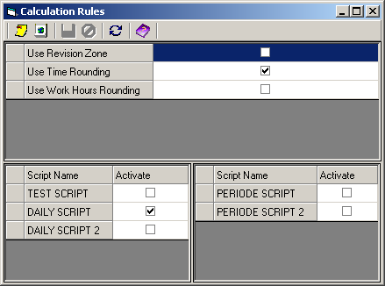

If you click New, Time & Attendance Script window will appear. Time & Attendance Script allows you to write down any attendance formula that you want. Note that only Visual Basic Script language is acceptable.

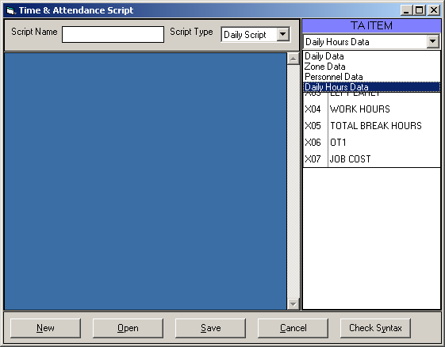

You may view or create new script name. To view, you just need to click Open and the existing script, as well as the program details, will appear.
To create new one, click New. Type a specific name in Script Name. Select an option in Script Type (Daily Script/Period Script), and its item in TA ITEM combo box.

There are four groups of data in TA ITEM, namely: Daily data (Work hour, Break hour, Regular hour, Late hour, and Left Early hour), Zone Data (Early OT Zone, OT, and Special Zone), Personnel Data (Department, Group, Position and Status), and Daily Hours Data.
You may add new item to the Daily Hours Data. Click Daily Hours Data on TA ITEM combo box, and then click the mouse’s right button. Click Add Daily Hours Data, and the following window will appear. Click New. Type a specific code and name in Item Code and Name, respectively. Type the appropriate type of the new item in Data Type. Finally, click Save to record the new item.

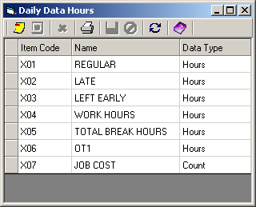

Now you can write the script using those available items. When you finish writing, click Check Syntax to check your program. If it succeeds, the Check Script Syntax window will appear.

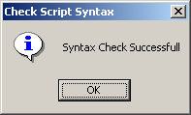

Click OK, and then click Save to record data.

Organization Type setup includes:
- Name: to fill the organization name
- Level: to fill the organization level in the organization hierarchy
- Description: to fill the description of the organization

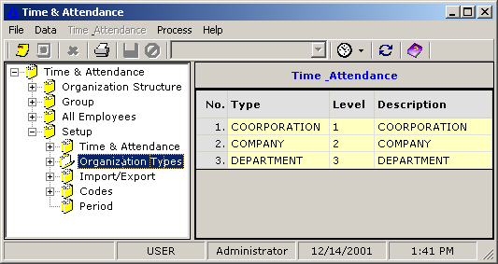

Import/Export setup includes:
- Import Employee Data
It is for setting up the digit codes distribution of data imported from Personnel Module
- Import Attendance Data
It is for setting up the digit codes distribution of data imported from attendance machine

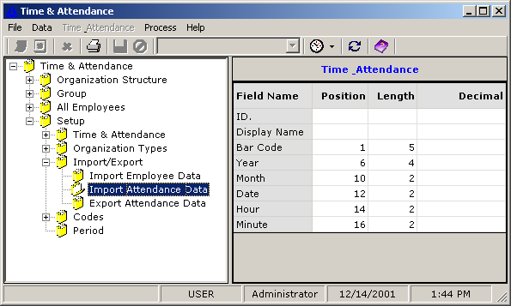

  - Field Name: specify a field name to import
  - Position: set the start position of the field name’s digit code
  - Length: set the length of the field name’s digit code

- Export Attendance Data
It is for setting up the digit codes distribution of data exported to Payroll Module

Codes setup is for setting up the personnel codes, such as employee’s position, status, work shift, etc.

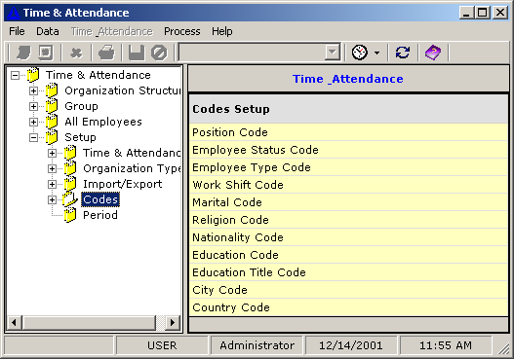

Period setup is for setting up period for calculation rules and for pay period.

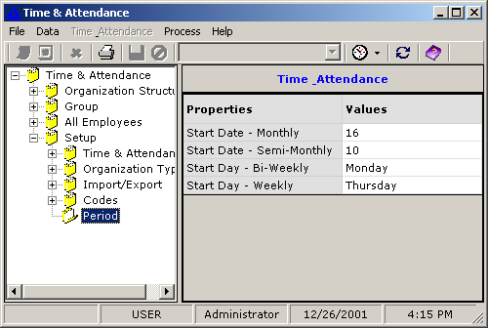

There are also icons and toolbars to assist your work.

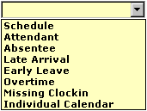

This combo box deals with employee’s attendance data, therefore it will be active only when employee data is actively displaying. Select an employee or group name, and then click the combo box. Select a component, and then select the period. The employees’ attendance data of the related period will appear.

Schedule. This function is for viewing employee’s schedule in particular period. Schedule displays the schedule name that employees belong to, while the date column shows the shift name of employee’s attendance on that specific day.

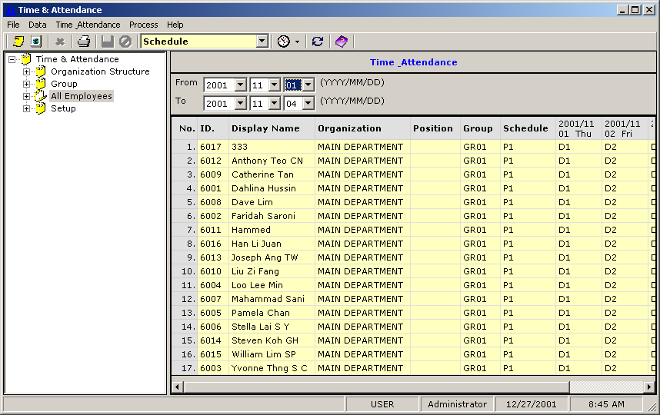

Attendant: to view attendants in a particular period. Look at the example below. On November 1, 2001 only six employees attended the workplace, as indicated in the number of the checkboxes being checked. It also shows the shift name that attendants belong to.
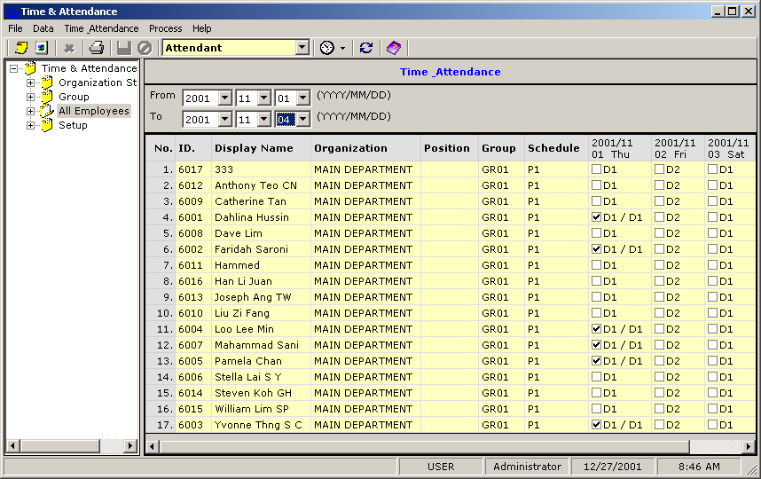

Absentee: to view absentees in a particular period. Look at the example below. On November 1, 2001 only six employees attended the workplace, as indicated in the number of unchecked checkboxes. It also shows the shift name that attendants and absentees belong to.

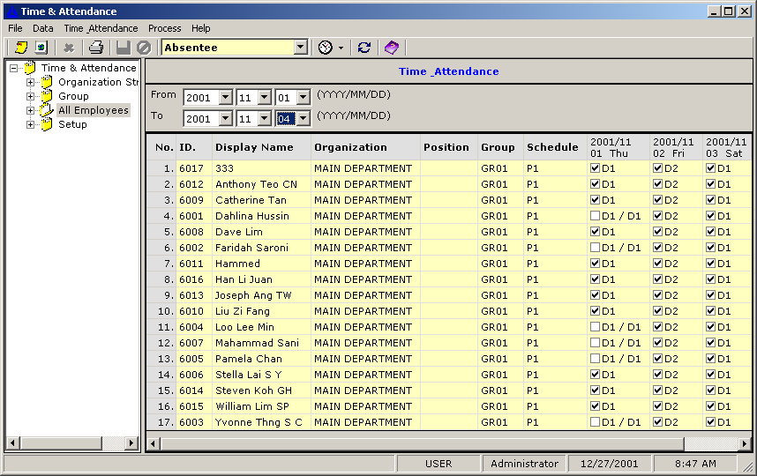

Late Arrival: to view employee’s late arrival in a particular period. The example below shows that two employees arrived late on November 1, 2001. It also displays the length of time of their unpunctuality.

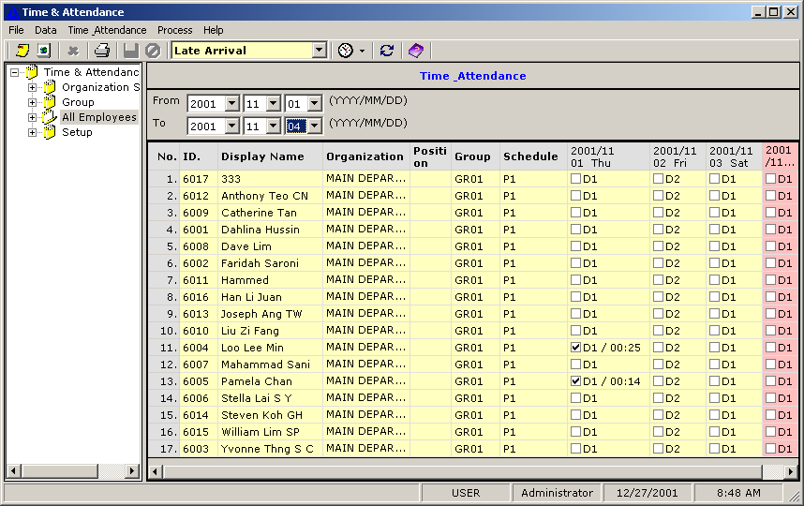

Early Leave: to view employee’s early leave in a particular period. The example below shows that only one employee left early on November 1, 2001. It also displays his earliness’ amount of time.

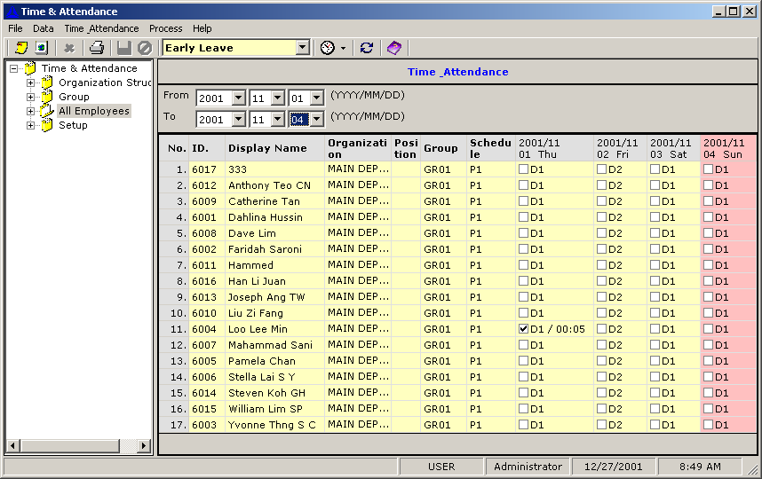

Overtime: to view employee’s overtime data in a particular period. The example below shows that five employees worked overtime on November 1, 2001, as indicated in the number of checkboxes being checked. It also displays their overtime’s duration.

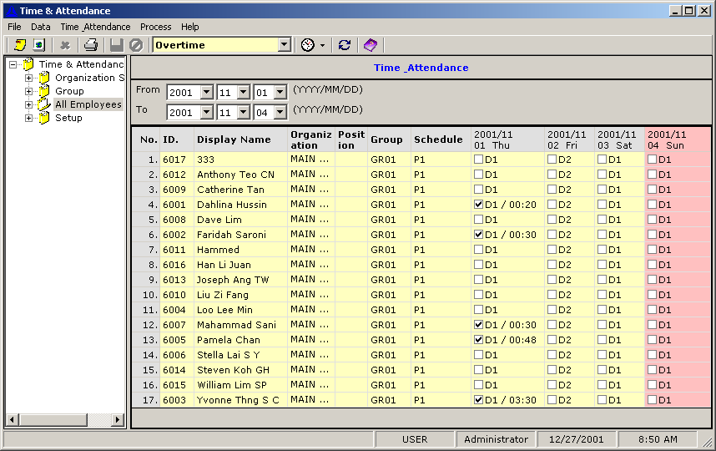

Missing Clocking. Missing Clocking is a term for imbalanced numbers of INs and OUTs. Employees must swipe every time they enter/exit the workplace. Once they forget to swipe, it will be a potential missing clocking case.

Individual Calendar: to view employee’s individual calendar in a particular period.

Daily Edit: to view and edit employee’s daily data. If you click this subfolder, the Daily Edit window will appear. There are three tabs to view and edit employee’s daily data, namely Dates to View, Result and Result Detail. Dates to View tab is for setting the range of date, particularly by clicking From and To combo box. You will see a table of the date range that you set. Click on the date you wish to be the first day to view, and then click-right the mouse. Two options will appear. Click First day. Take similar steps for setting the last day, only this time you must select Last day.

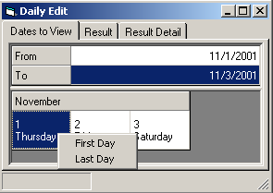

To view the result briefly, click Result. The Result Detail facilitates you to view employee’s daily attendance data more closely, as well as to edit them.

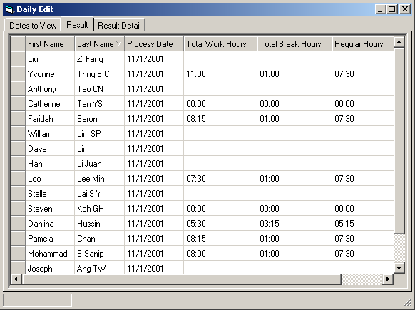

Click on employee’s name whose attendance data you wish to view. Click Result Detail, and then his/her attendance data will appear.

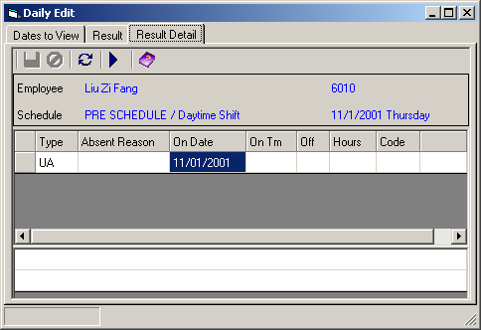

Type covers the attendance type. There are some common attendance types:
WRK = work
BRK = break
UA = unexpected absent
UNP = unpaid IN
AL = annual leave
OL = other leave (vacation leave, etc)

Absent Reason is for explaining the reason of employee’s absence. You may submit employee’s reason on his/her absence by clicking this cell, and then click in it. The Absent Reason window will appear.

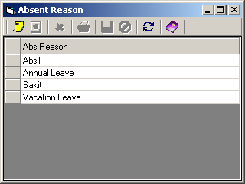

Click an absence reason option, and then right-click the mouse. Click Select.

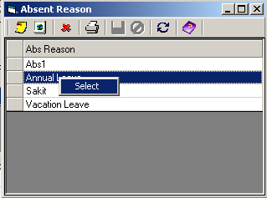

Click Save to record the data.

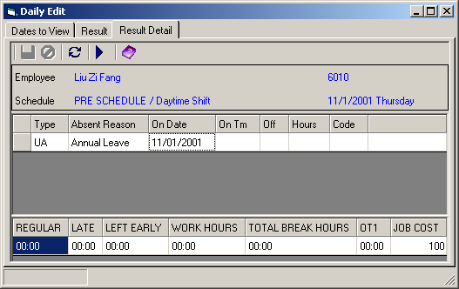

On Date reveals the date of the employee’s attendance data.
In highlighted row (WRK), On Time reveals the time when employee swipes in. Conversely, in un-highlighted row, it reveals the time when employee swipes out.
In highlighted row (WRK), Off reveals the time when employee swipes out. Conversely, in un-highlighted row, it reveals the time when employee swipes in.
Hours reveals the hours spent on activity of the associate row.
In any case of extreme unpunctuality, Code is a mean to submit a reason explaining the unpunctuality.
For instance:

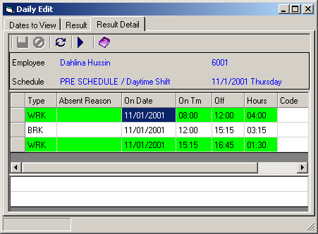

In her case, three-and-a-quarter hour break would be acceptable if she had a good reason. She may submit her reason by double-clicking the Code cell, to call Management Code window.

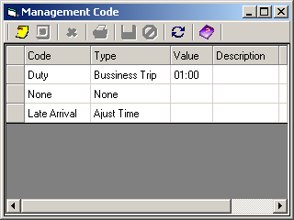

Code expresses a specific code for unpunctuality reasons, while Type explains its type. Value limits the amount of time allowed for the unpunctuality.
She may click the most appropriate reason, and then right-click the mouse to claim the reason. (If she cannot find any, she may click None)

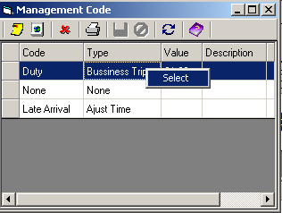

Click Select, and then click Save to record the data. The reason is now displayed in Code. Click Recalculate, and the calculation result will change.

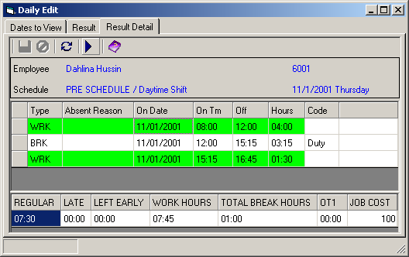

After the reason submitted, her Total Break Hours is adjusted to one hour (as stated in the Management Code setting), instead of three hours. Her Work Hours is adjusted as well.
Otherwise, if she clicks None, then the calculation result will appear like this:

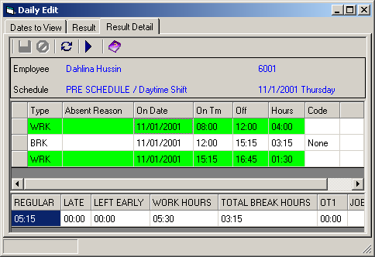

It means that her three-hour-break remains unexplained, hence there is no adjustment needed for it.

